**MICROSERVICES WITH SPRING BOOT 3 AND SPRING CLOUD**

**CREATING MICROSERVICES FOR ACCOUNT AND LOAN**

**ACCOUNT MICROSERVICE**

**CODE:**

**AccountController.java**

package com.cognizant.account.controller;

import org.springframework.web.bind.annotation.*;

*@RestController*

*@RequestMapping*("/accounts")

public class AccountController {

*@GetMapping*("/{number}")

public Account getAccountDetails(*@PathVariable* String number) {

return new Account(number, "savings", 234343);

}

static class Account {

private String number;

private String type;

private double balance;

public Account(String number, String type, double balance) {

this.number = number;

this.type = type;

this.balance = balance;

}

public String getNumber() { return number; }

public String getType() { return type; }

public double getBalance() { return balance; }

}

}

**AccountApplication.java**

package com.cognizant.account;

import org.springframework.boot.SpringApplication;

import org.springframework.boot.autoconfigure.SpringBootApplication;

@SpringBootApplication

public class AccountApplication {

public static void main(String[] args) {

SpringApplication.run(AccountApplication.class, args);

}

}

**OUTPUT:**

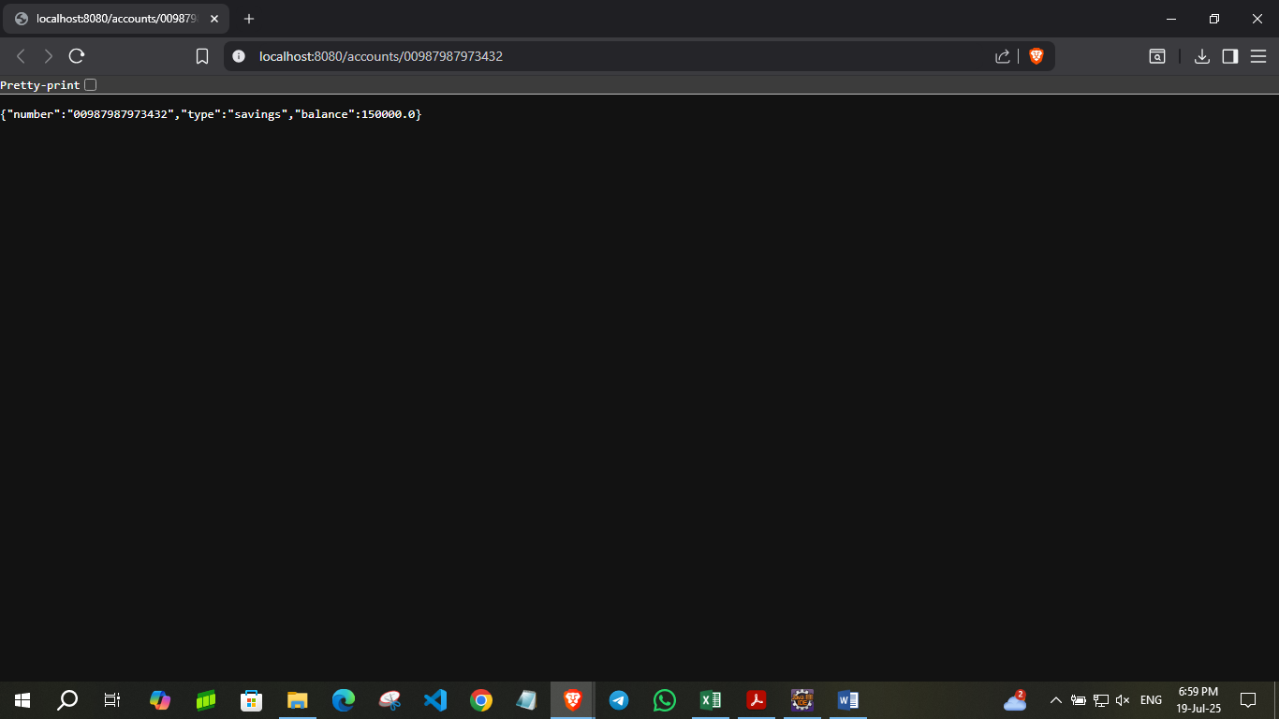

**LOAN MICROSERVICE**

**CODE:**

**LoanController.java**

package com.cognizant.loan.controller;

import org.springframework.web.bind.annotation.*;

*@RestController*

*@RequestMapping*("/loans")

public class LoanController {

*@GetMapping*("/{number}")

public Loan getLoanDetails(*@PathVariable* String number) {

return new Loan(number, "car", 1500000, 5000, 24);

}

static class Loan {

private String number;

private String type;

private int loan;

private int emi;

private int tenure;

public Loan(String number, String type, int loan, int emi, int tenure) {

this.number = number;

this.type = type;

this.loan = loan;

this.emi = emi;

this.tenure = tenure;

}

public String getNumber() { return number; }

public String getType() { return type; }

public int getLoan() { return loan; }

public int getEmi() { return emi; }

public int getTenure() { return tenure; }

}

}

**LoanApplication.java**

package com.cognizant.loan;

import org.springframework.boot.SpringApplication;

import org.springframework.boot.autoconfigure.SpringBootApplication;

@SpringBootApplication

public class LoanApplication {

public static void main(String[] args) {

SpringApplication.run(LoanApplication.class, args);

}

}

**OUTPUT:**

